A000-Mex-Monte Albán I-Globular Pot with Appliques-Ceramic-300-600 CE

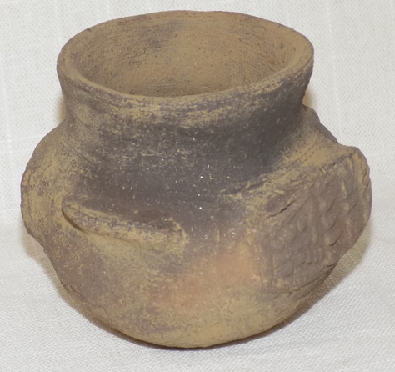 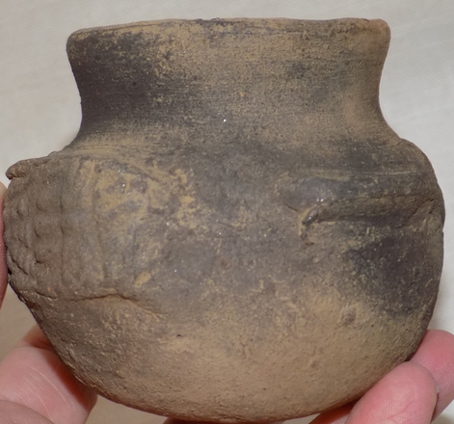 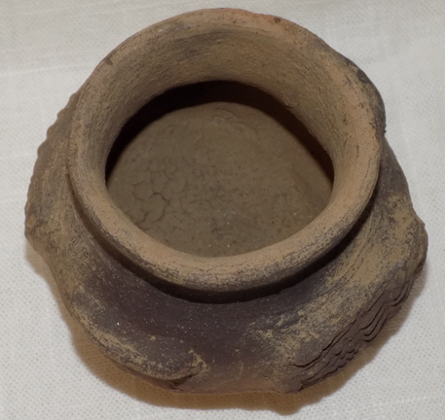

**Case no.: 10**

**Accession Number:**

**Formal Label:** Mex-Monte Albán I-Globular Pot with Appliques-Ceramic-300-600 CE

**Display Description:**

There are two rectangular appliques on the sides of this globular vessel. On one side is a mouth with many teeth exposed and on the opposite side there is an image of Tlaloc turned at 90o.

**LC Classification:**

**Date or Time Horizon:** 300-600 CE

**Geographical Area:** Monte Albán, Oaxaca, Mexico

**Map:**

**GPS coordinates:**

**Cultural Affiliation:**

**Media:**

**Dimensions:** Dimensions: 3" x 4"

**Weight:**

**Condition:** Visible Root Marks, Mineral Deposits, Obvious Signs of Erosion

**Provenance:** Origin: Oaxaca, Mexico- Previous Collector has tag that reads "Monte Alban"

**Discussion:**

**References:**